Smart baby seat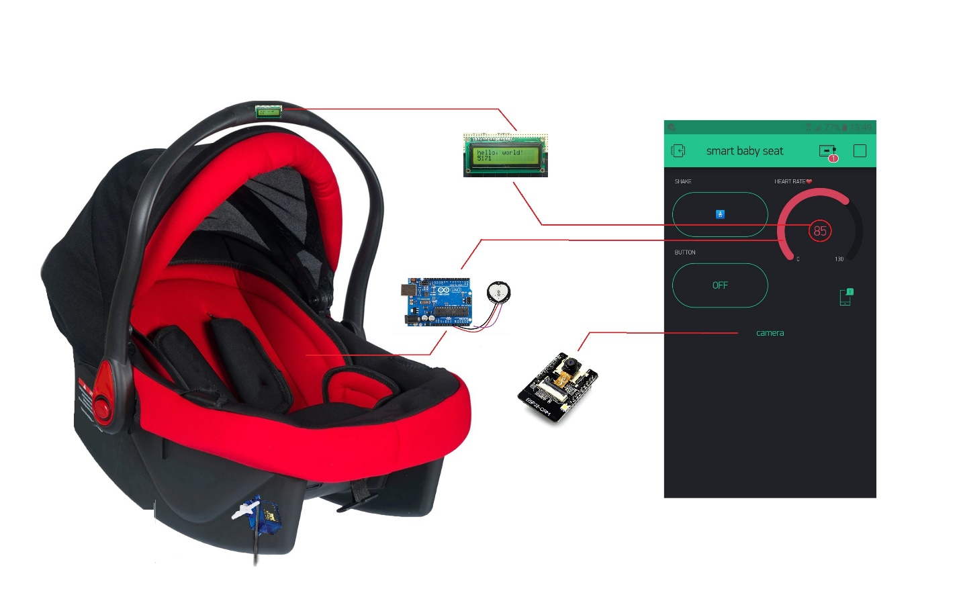

Karabuk university

Computer engineering department   
**this project was supervised by :**

**Dr.Öğr.Üyesi OMAR DAKKAK**students names :

Abdulaziz damlahi 2015710213037

Akram alkddeh 2016710213059

Bashar KHATIB 2015710213101

**Introduction**

This project is about making a smart baby seat that can send and receive the information through mobile phone

Our aim is to keep the baby under monitoring and observe heart rate and other stuff that we are going to make a brief explanation in this paper work.

**The main components**

1. **Node MCU:** We have chosen the Arduino controller which is specifically called node MCU as main chip

The main feature that this chip is providing WIFI connection that can send and receive data.

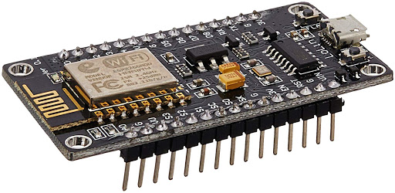

**The library used and the configuration of the WIFI connection**

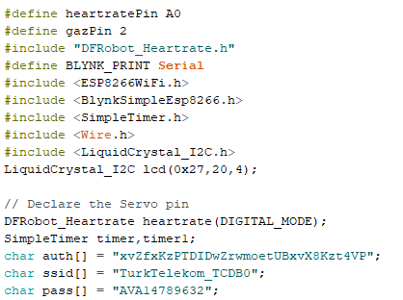

**2.arduino uno:** the main function of this device is to receive information from other sensor and send them to node MCU to communicate this information again thro WIFI.

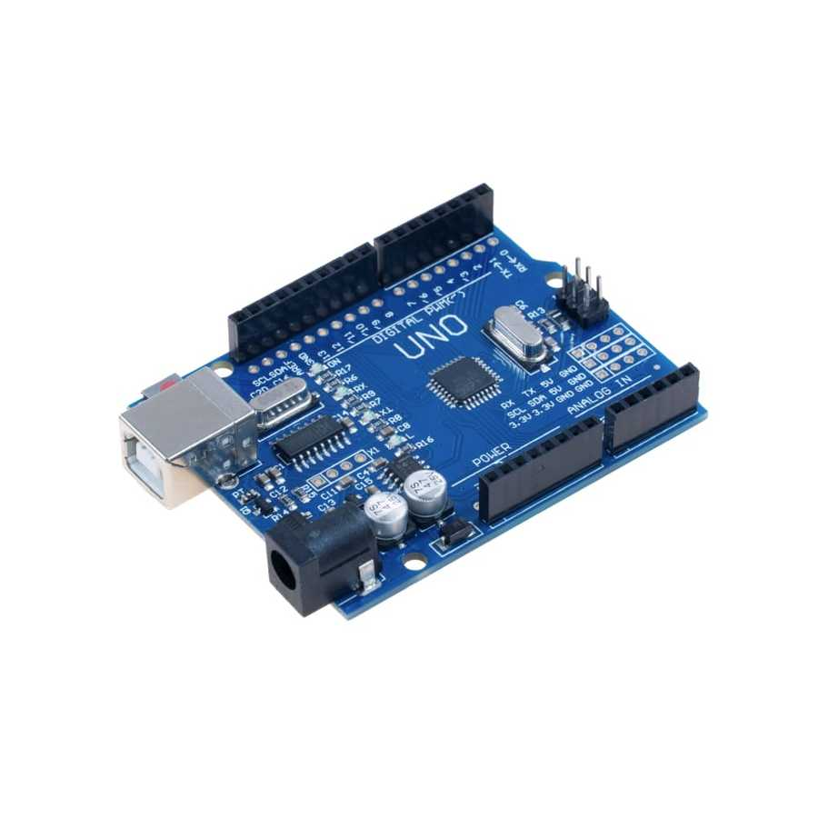

**3.heart rate sensor:** this sensor is responsible for measuring the heart rate by placing the sensor on the rest of the baby and sending the information to node MCU that is going to send it again to the mobile application

During code part we distinguish between the normal heart rate in the sleeping mode and awake mode

The heart rate sensor is configured to send a command to a buzzer if the heart rate was too high

(the normal heart rate for a baby between 3 months and less than 3 years old baby is between 80-120 bpm)

the first problem we were getting weird numbers by the sensor we applied too many changes on the hardware and software parts but it did not work so we eventually found out that it’s because of the quality of the sensor so we managed to change it.

the second Problem that we had faced while coding the heart rate sensor we have faced a problem that we had a delay while running the code with this sensor because there were two or more functions that’s why the sensor could not send the data on the appropriate time so we managed to minimize the number of functions.

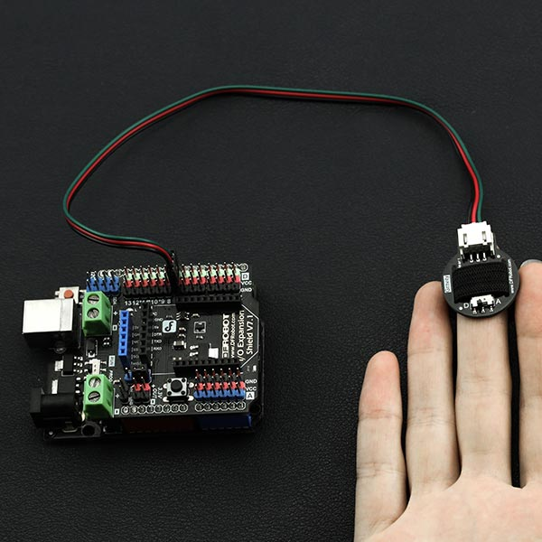

**This is the function used for receiving the data from the heart rate sensor at each interval of a time and its stored in the node MCU**

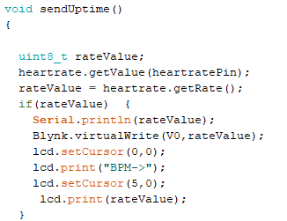

**4. esp32 camera:** this camera is used ininternet of things project and it provides a live stream directly to the mobile phone because it has built-in WIFI controller by it self

By attaching it to baby seat handle and face it to the baby

Face

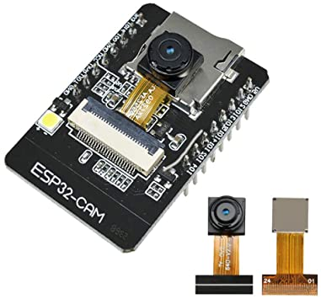

**And this is the scheme of writing the code to the ESP camera from Arduino UNO**

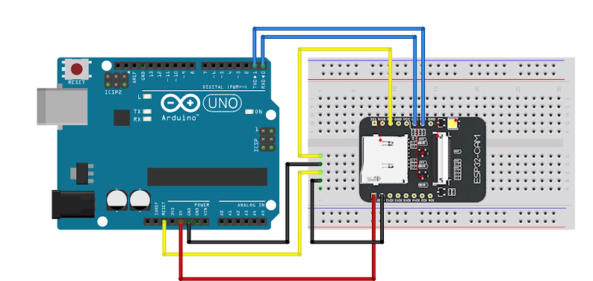

**5.servo motor:** Servo implies an error sensing feedback control which is utilized to correct the performance of a system. It also requires a generally sophisticated controller, often a dedicated module designed particularly for use with servomotors. Servo motors are DC motors that allow for precise control of the angular position. They are DC motors whose speed is slowly lowered by the gears. The servo motors usually have a

revolution cut off from 90° to 180°. A few servo motors also have a revolution cutoff of 360° or more. But servo motors do not rotate constantly. Their rotation is limited between the fixed angles this servo motor sends the data to the Arduino chip using Technik called master and slave

between Arduino UNO and node MCU.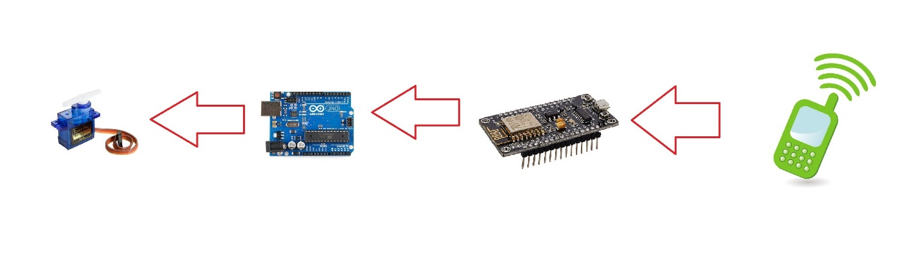

**The following code is sending the output to the servo motor after receiving the command from cell phone and pass through node MCU to Arduino UNO to servo motor**

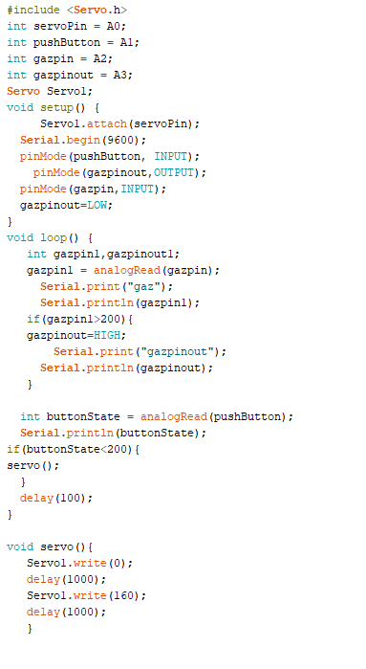

the third Problem was to hang the servo to the back of the seat so the solution was little bit complicated we used apps to design 3d stick that can help the servo hang on the seat.

**6.LCD(16X2):** this is a simple LCD screen used to display all of the information of the baby like heart rate read and if the baby was crying (we can know that by check heart rate read of the baby ) throw to the sound sensor warning to a active the voice notification .

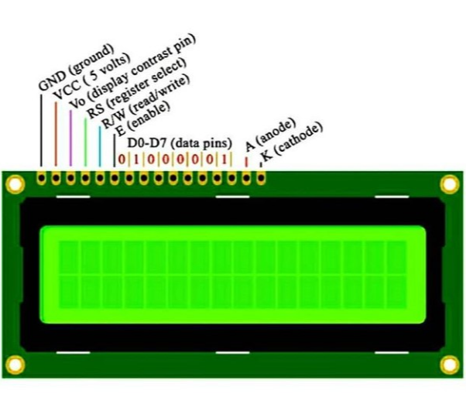

**And this is an example of printing on the LCD screen and its stored inside each function in node MCU**

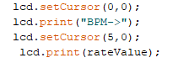

**Photo of the project that show the part used**

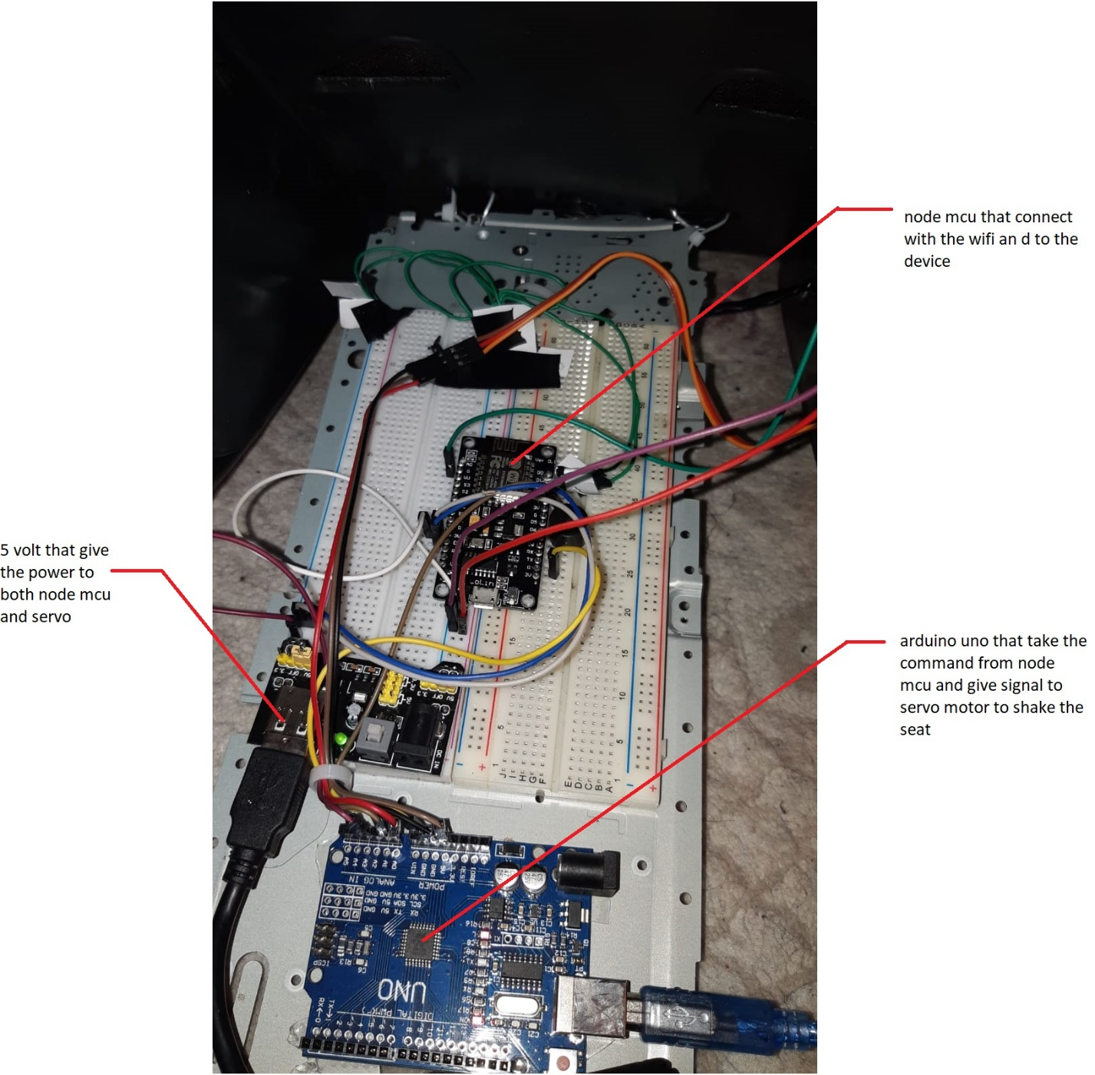

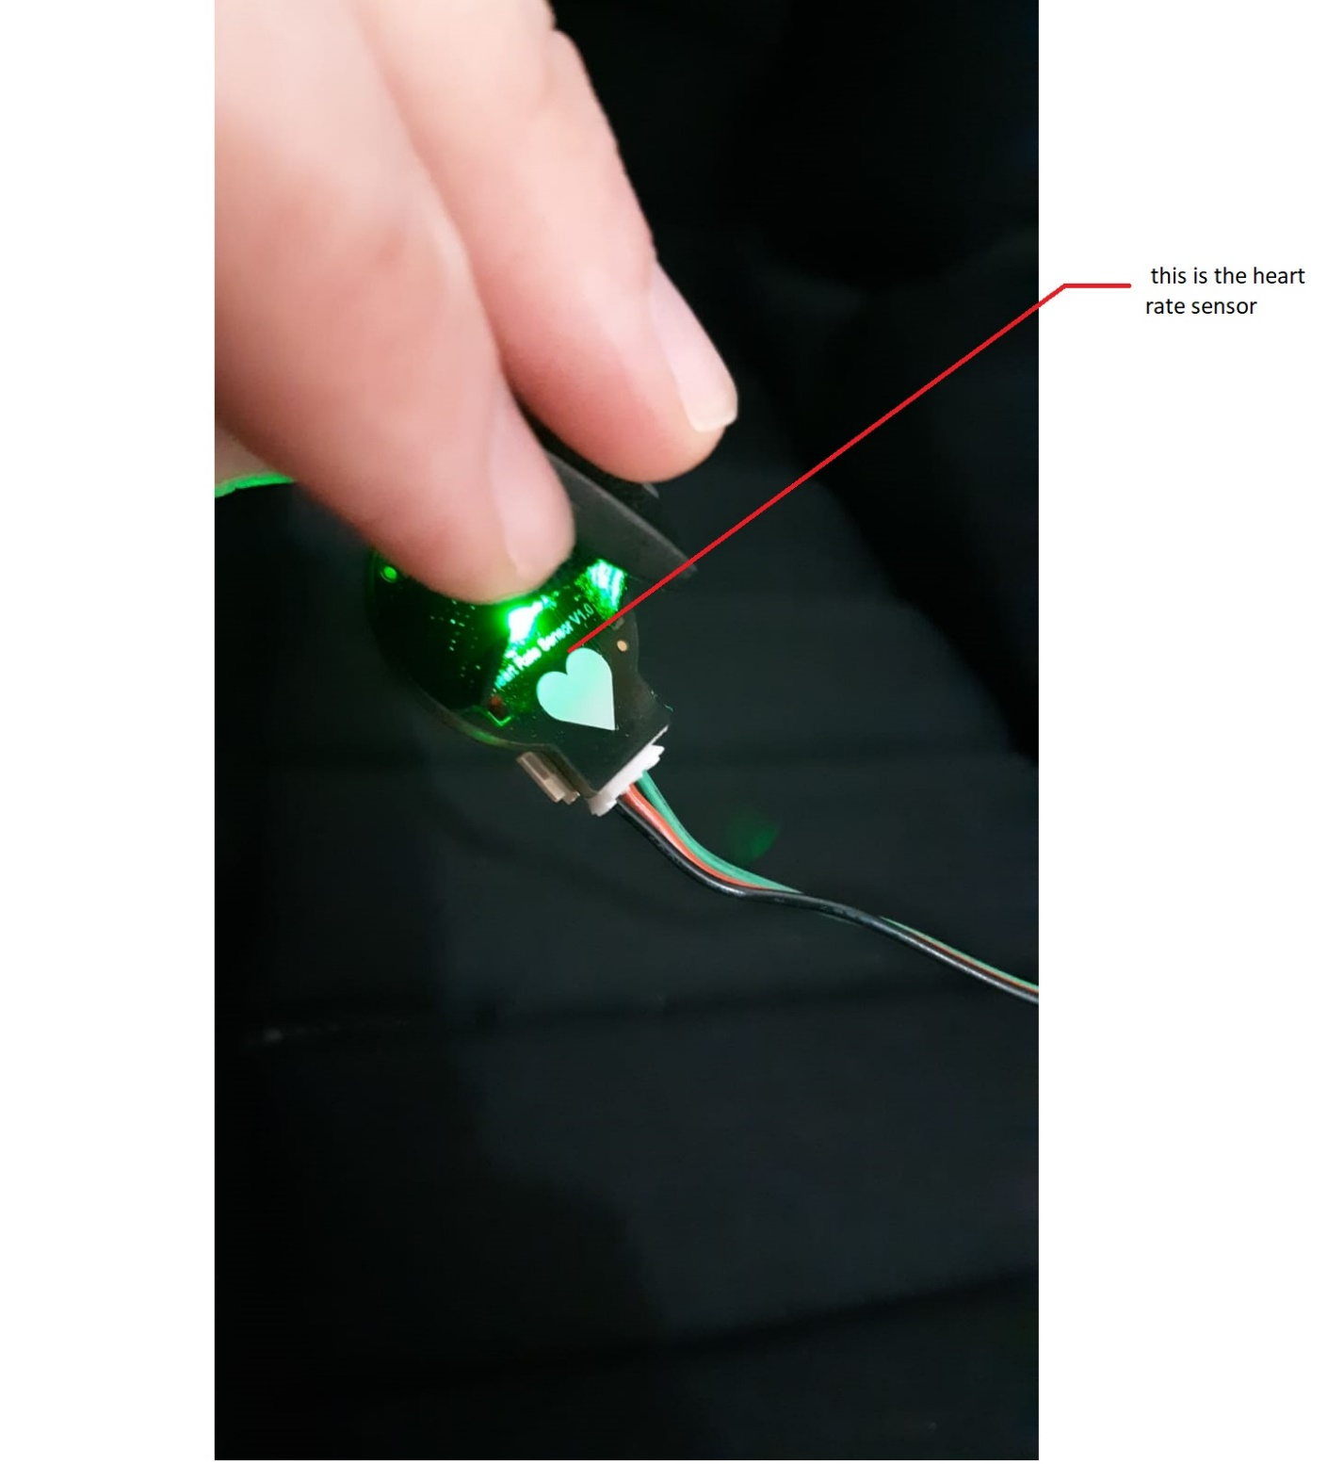

**The app interface**

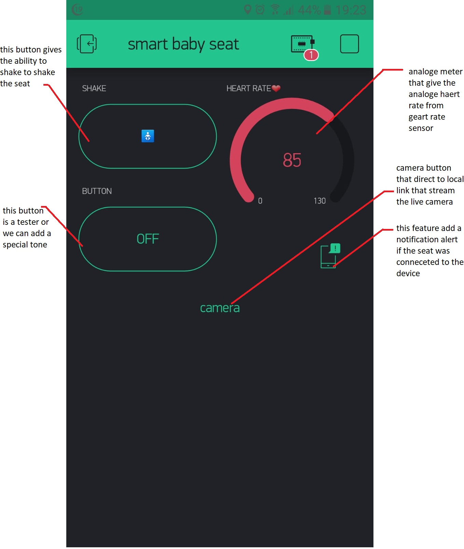

**The full scheme of the circuit**

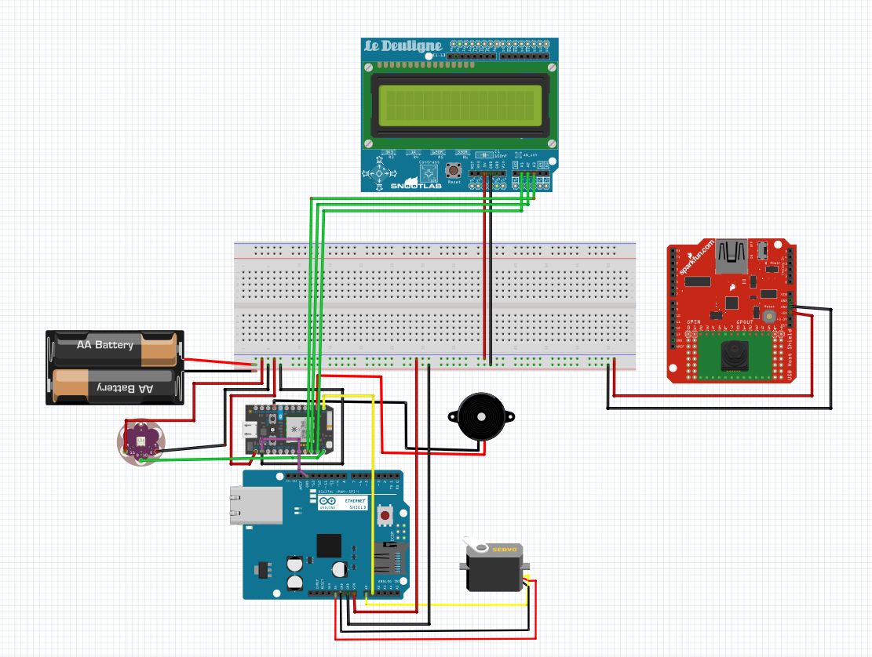

References :  
<https://avesis.karabuk.edu.tr/omardakkak>  
<https://www.arduino.cc/>  
<https://fritzing.org/home/>